**A Comprehensive Bibliometric Analysis of Learning Analytics in Education Research**

|  |
| --- |
|  |

**Abstract**

The purpose of this study is to present data on the use of learning analytics in the field of education. For this purpose, data available in the Web of Science database were examined using bibliometric analysis. The publication distribution varied between 2011 and 2022, with the number of publications reaching its peak in 2020 and declining thereafter. Findings from co-authorship analysis indicate that Dragan Gašević is the most prolific author and the most cited researcher in the field of learning analytics. Results of co-authorship analysis by country suggest that researchers affiliated with institutions in Australia engage in more collaborative work and cooperation. Results of co-authorship analysis by organizations demonstrate that Monash University in Australia is the organization with the highest level of collaboration with other organizations. The most cited work is Ferguson's (2012) article titled "Learning analytics: drivers, developments and challenges." The most frequently used keywords in conjunction with learning analytics are higher education, educational data mining, online learning, learning design, and self-regulated learning. In recent years, there has been a focus on learning analytics related to learning management systems (LMS) rather than MOOCs in learning environments. The British Journal of Educational Technology, which was established in 1970, is the most cited journal that is commonly referenced in the articles. It is hoped that this study will serve as a valuable reference for researchers interested in the field and guide them in making accurate inferences based on a broad perspective.

**Keywords:** learning analytics, education, bibliometric analysis, voswiever

**Introduction**

The digitalization of learning necessitates the analysis of learners' behaviors in online learning environments. This situation also enables the examination of large datasets. It is, in fact, a comprehensive evaluation process that we cannot adequately achieve in face-to-face learning. When it comes to online learning, we gain the opportunity to observe the learner's individual efforts. In this regard, it may be appropriate to explain the function of learning analytics by relating it to a famous literary figure's comment on learning. Renowned writer Marcel Proust stated that the elements of the art of learning are will, order, and time. Learning analytics aims to reveal data related to these three elements, enabling more comprehensive and objective evaluations of students. While Marcel Proust's statements about learning are indeed relevant, a more detailed definition of learning analytics was provided at the Conference on Learning Analytics and Knowledge (LAK) in 2011: "Learning analytics is the measurement, collection, analysis, and reporting of data about learners and their contexts, for purposes of understanding and optimizing learning and the environments in which it occurs." Another widely accepted definition was proposed by Siemens (2010): "Learning analytics is the use of intelligent data, learner-produced data, and analysis models to discover information and social connections, and to predict and advise on learning."

Formun Üstü

Learning analytics is a rapidly developing field within technology-enhanced learning research, and it has strong roots in various disciplines (Ferguson, 2012). Educational organizations worldwide are increasingly leveraging learning analytics technologies to achieve more effective and efficient learning processes. As a result, the number of researchers working in this area is growing every day. The most cited scholars in the field and the influential sources that shape the field are among the important topics that researchers conducting future studies should be familiar with.

Furthermore, there are many higher education organizations that host research on learning analytics and collaborate with researchers from other universities. Understanding these collaborations and density maps can be beneficial for researchers and practitioners involved in learning analytics studies.

There are some requirements for the concept of learning analytics to become a field:

-Educational data mining based on the need to meet technical needs: how can we make sense of big data about learning?

- The need to ensure educational improvement: how can we provide better learning in online environments?

-Academic analytics focusing on political-economic needs: How can we significantly improve learning opportunities and educational outcomes at national or international levels? (Ferguson, 2012).

Therefore, the concept of learning analytics encompasses educational data mining and academic analytics. The motivation for adopting learning analytics processes can vary based on specific needs. Some motivations include predicting student success and providing proactive feedback (Dawson et al., 2014). Additionally, modeling learner behavior, enhancing self-awareness and self-reflection, predicting dropout rates, improving assessment and feedback services, ensuring participation and satisfaction, and user acceptance and recommendation systems are among the most studied topics in the field (Papamitsiou and Economides, 2016). Observing the keywords used in research can provide us with a different perspective on the overall framework of research topics. In addition, the change of popular topics according to years can be seen with keyword analysis. Thus, researchers can get an idea about the subjects that need more study.

There are systematic review studies that compile various research findings related to learning analytics. These studies provide insights into research and implementation trends, methodological trends, and general implications of the impact. For example, Wong (2017) examined the use of learning analytics in higher education institutions through personalized assistant-driven online distance learning (ODL) and conducted a meta-analysis on the effects of learning analytics initiatives on student success. The researcher noted that the number of studies providing quantitative data on learning analytics is limited. Existing intervention studies mainly rely on discussions and interactions between students and instructors.

Wong et al. (2018) conducted another study that examined research on learning analytics techniques in higher education institutions. This study analyzed the characteristics of institutions, features of learning analytics applications, observed outcomes in institutions, and trends in learning analytics applications in studies indexed in the Scopus database from 2007 to 2016. The results showed that in recent years, learning analytics research has been predominantly focused on analyzing student behavior, followed by increasing cost effectiveness.

Formun Üstü

Wong and Li (2020) conducted a review study on interventions in learning analytics research between 2011 and 2018. The researchers categorized and summarized a total of 24 intervention studies based on their objectives, data, intervention methods, obtained results, and encountered challenges. The results indicated the need for more experimental studies on the effects of intervention in learning analytics research.

In their study examining MOOC learning analytics research between 2011 and 2021, Zhu, Sari, and Liu (2022) identified prominent data analysis techniques. The analysis methods used were as follows, in descending order: statistics (n=133), machine learning (n=43), content analysis (n=23), social network analysis (n=22), text analysis (n=17), data visualization (n=14), thematic analysis (n=5), and interaction analysis (n=5).

These systematic review studies provide valuable insights into research and application trends, methodological approaches, and general outcomes in the field of learning analytics. Research in learning analytics is important for revealing the concentration of analytics in different organizations, the types of needs that provide a foundation for learning analytics, and the usage of learning analytics for different learning outcomes. However, as seen in the mentioned studies, systematic reviews on learning analytics have been limited to specific topics such as organizations, students, or trends. In this study, the analysis involves a wide network of data that encompasses inter-organizational collaborations, inter-author collaborations, and keywords or trends.

Therefore, the objectives of this study are as follows:

* To analyze collaborative authorship in relation to studies in the field of learning analytics and map collaborations between countries, authors, and organizations.
* To determine influential references through the analysis of a common reference citation network.
* To provide a comprehensive perspective on learning environments within the application domain, the effects of learning analytics on learning outcomes, and data related to participant levels through keyword analysis.

**Method**

This study analyzed published works on learning analytics using the bibliometric analysis method in the Web of Science indexed database. "Bibliometrics relies on quantitative measurements of qualitative aspects of the scientific system" (Rehn, Gornitzki, Larsson, & Wadskog, 2014). Bibliometric analysis is important in generating useful results for researchers and practitioners. It reveals authorship, country, and organizational collaborations, and allows for the analysis of keyword-related data density. Thus, it enables inferences regarding the most studied and necessary research topics in the selection of research subjects.

**Data Collection**

The data for this research were accessed on December 15, 2022, through the Web of Knowledge website. The choice of the Web of Science database was due to its valuable indices and its prestige as a database used to access academic publications. During the data collection process, the "topics" category was selected on the Web of Science Core Collection website, and the search term "learning analytics" was used to retrieve the results. Two criteria were considered in the search: document type and WoS category. Only articles were included in the analysis, and other types of publications were excluded. The analysis was conducted specifically on articles categorized under "Education Educational Research" in the WoS categories. An overview of this process is provided in Figure 1.

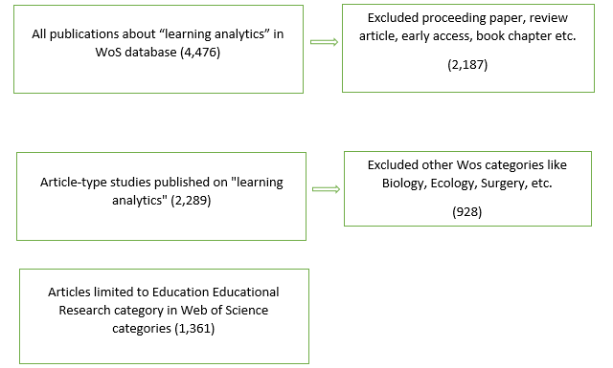

*Figure 1: Steps Illustrating The Process Of Accessing Research Data In The WoS Database*

**Data Analysis**

Bibliometric analysis technique was employed for the analysis of research data. Pritchard (1969), defined bibliometric analysis as the application of mathematics and statistical methods to books and other scientific communication tools. In this study, a total of 1361 publications related to learning analytics published from 2011 to 2023 were analyzed and categorized based on bibliometric indicators. The collaboration levels of authors in the field, the distribution of publications in countries and organizations through co-authorship analysis, influential citation sources shaping the field through co-reference citation network, and the topics and orientations of academic publications were visually mapped using keywords. The 1361 data within the scope of the research were mapped using the VOSviewer analytical tool. VOSviewer is one of the network software tools compatible with all operating systems. It is highly functional in the easy visualization and interpretation of large bibliometric maps (Van Eck & Waltman, 2010).

**Findings**

**Findings related to the distribution of publications and citations over the years**

The distribution of academic studies and citations related to learning analytics over the years is presented in Figure 2*.*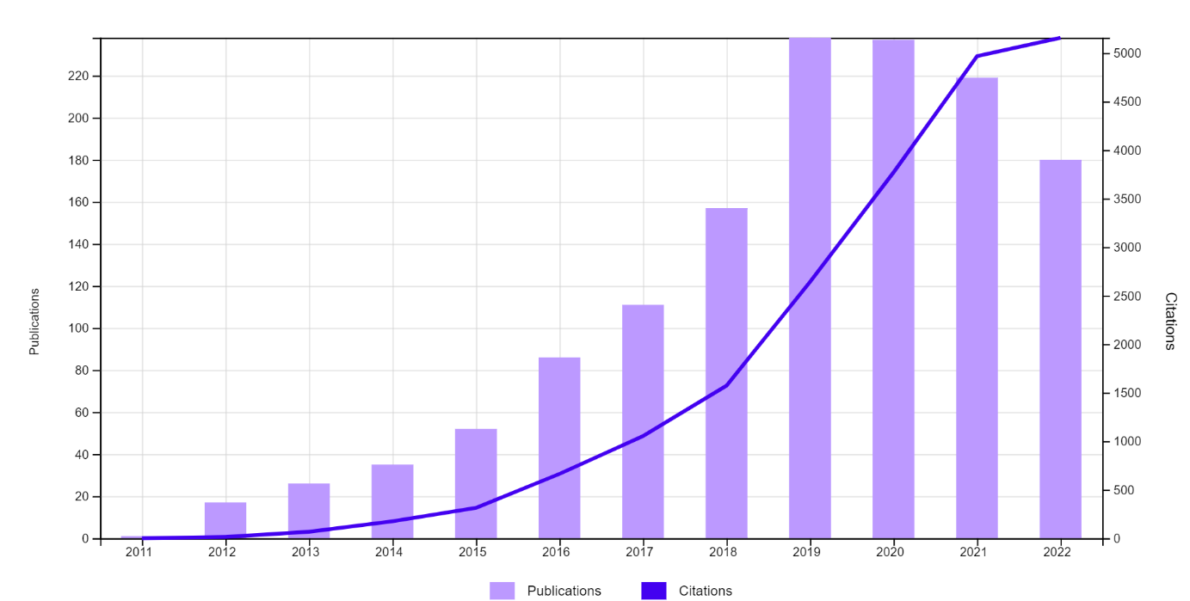

*Figure 2: Publication and Citation Counts By Year*

As shown in Figure 2, the distribution of publications varies between 2011 and 2022, with the highest number of publications reached in 2020 followed by a decline. However, there is no noticeable decrease in the number of citations. This graph indicates that the field of learning analytics has become a research area that is losing its popularity. One possible reason for this could be the increased emphasis on face-to-face education as the pandemic comes to an end.

**Findings from co-authorship analysis**

**Co-authorship by authors**

Co-authorship analysis revealed that among the 1,361 data obtained from the database, the total number of authors who have at least one document and received at least one citation is 2,628. However, when the citation threshold is set at 50, the number of authors is reduced to 266.

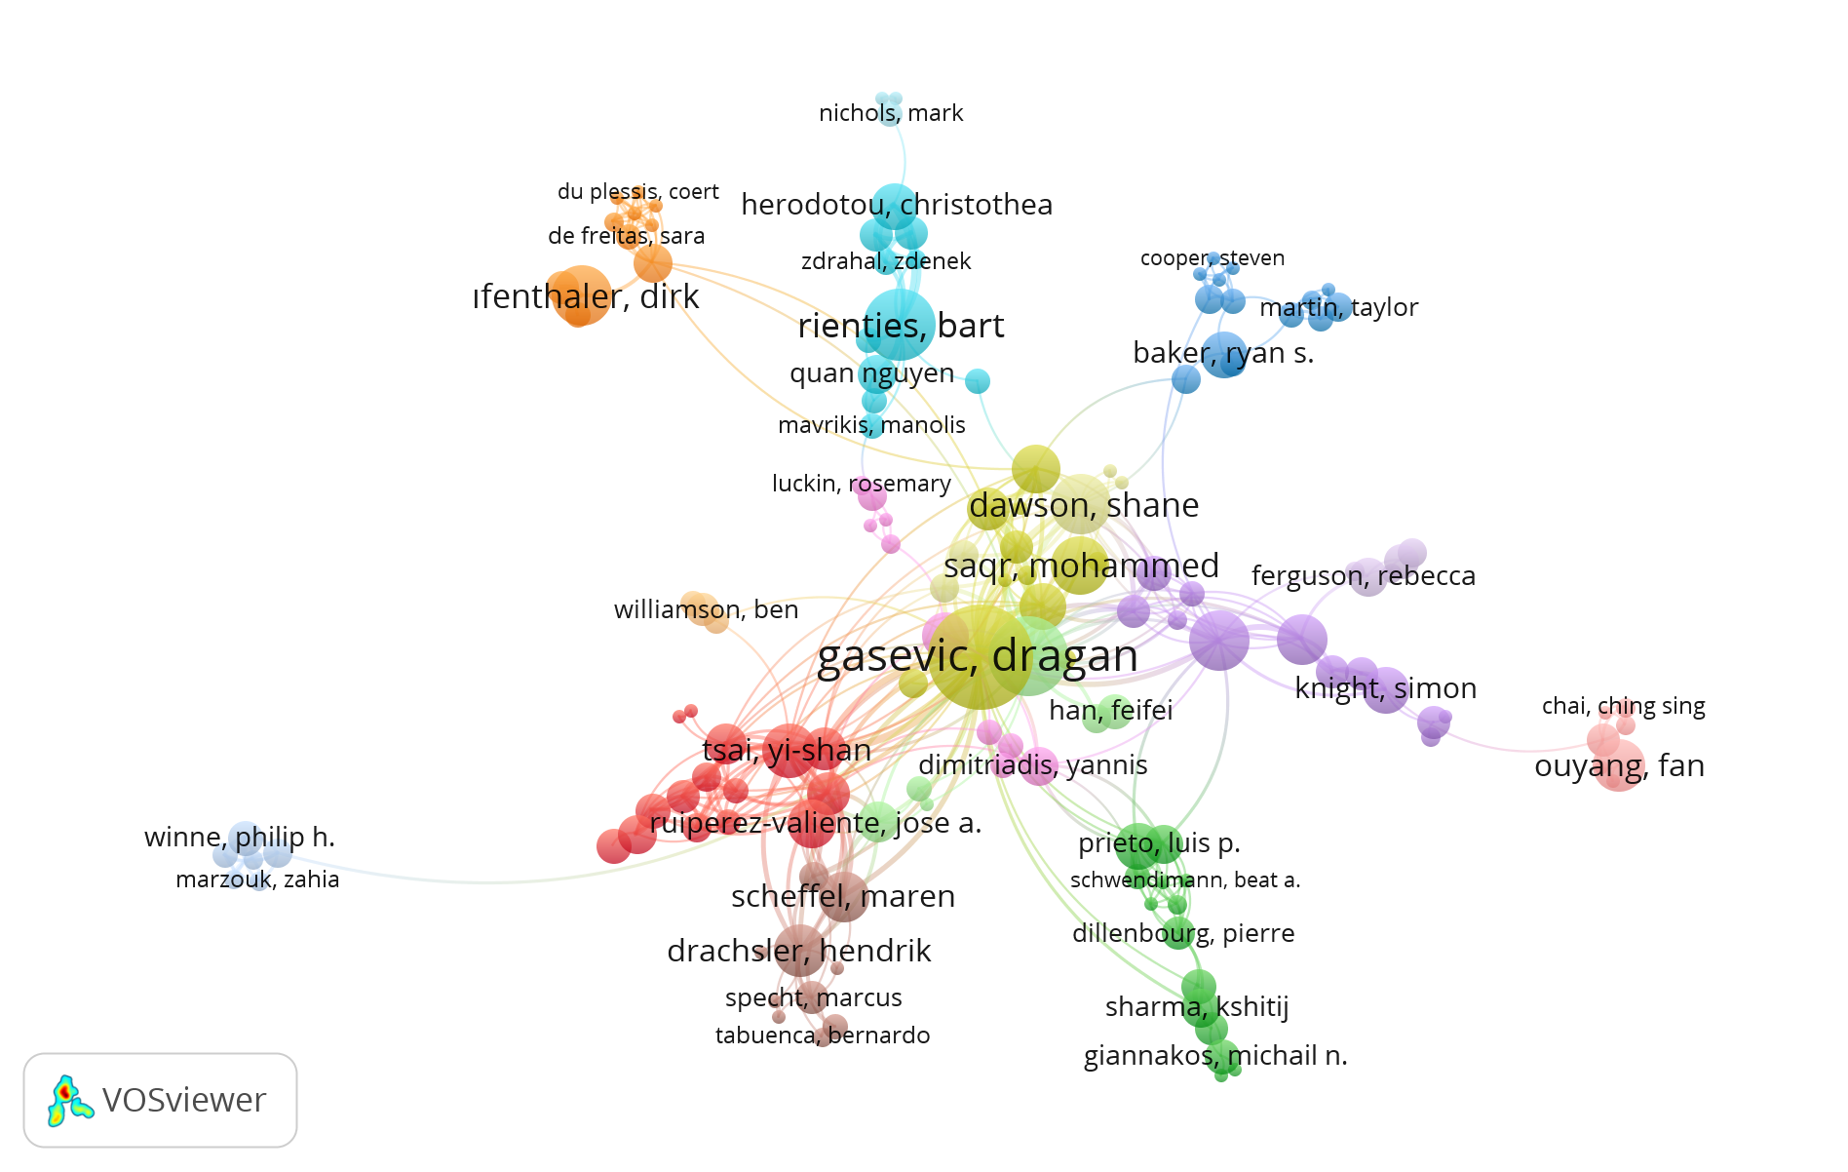

*Figure 3: Co-Authorship By Authors Network*

Figure 3 displays different clusters represented by different colors. Authors who have collaborated on the same work and received citations are shown within the same cluster. In this network structure, there are a total of 16 clusters, 144 items, and 436 links. When examining the centrality of the clusters, it can be observed that the yellow cluster is the most central and has the strongest relationships with other clusters. It is also noted that Dragan Gasevic is the researcher with the highest number of publications and citations in this field. Upon closer inspection of the yellow cluster, it is seen that academics such as Jovanovic, J., Saqr, M., Dawson, S., Kovanovic, V. are part of this cluster. Table 1 provides a list of the top 15 authors who collaborate the most and have the highest link strength in terms of total link strength.

**Table 1.** Authors with the most collaboration in the field of learning analytics

|  |  |  |  |
| --- | --- | --- | --- |
| **Author** | **Documents** | **Citations** | **Total Link Strength** |
| Dragan Gasevic | 51 | 1991 | 143 |
| Abelardo Pardo | 29 | 1058 | 78 |
| Yi-shan Tsai | 14 | 242 | 62 |
| Shane Dawson | 17 | 1318 | 51 |
| Alexander Whitelock-Wainwright | 9 | 139 | 45 |
| Pedro j. Munoz-Merino | 9 | 161 | 43 |
| Maren Scheffel | 12 | 224 | 43 |
| Hendrik Drachsler | 13 | 697 | 42 |
| Jelena Jovanovic | 10 | 590 | 34 |
| Bart Rienties | 24 | 426 | 34 |
| Roberto Martinez-Maldonado | 17 | 287 | 31 |
| Mar Perez-Sanagustin | 8 | 426 | 31 |
| Srecko Joksimovic | 9 | 290 | 29 |
| Tom Broos | 5 | 71 | 28 |
| Vitomir Kovanovic | 11 | 299 | 27 |

When examining Table 1, it is noteworthy that Yi-shan Tsai ranks third despite not having a very high number of publications and citations. This indicates that the author has strong connections with other researchers. It can be inferred that the author has collaborated with numerous researchers.

**Co-authorship by country**

Figure 4 depicts the inter-country collaboration in terms of co-authorship in publications related to learning analytics. Each combination in the analysis represents a country. The size of the combinations represents the number of published articles, while the distance and thickness of the connection lines indicate the level of collaboration.

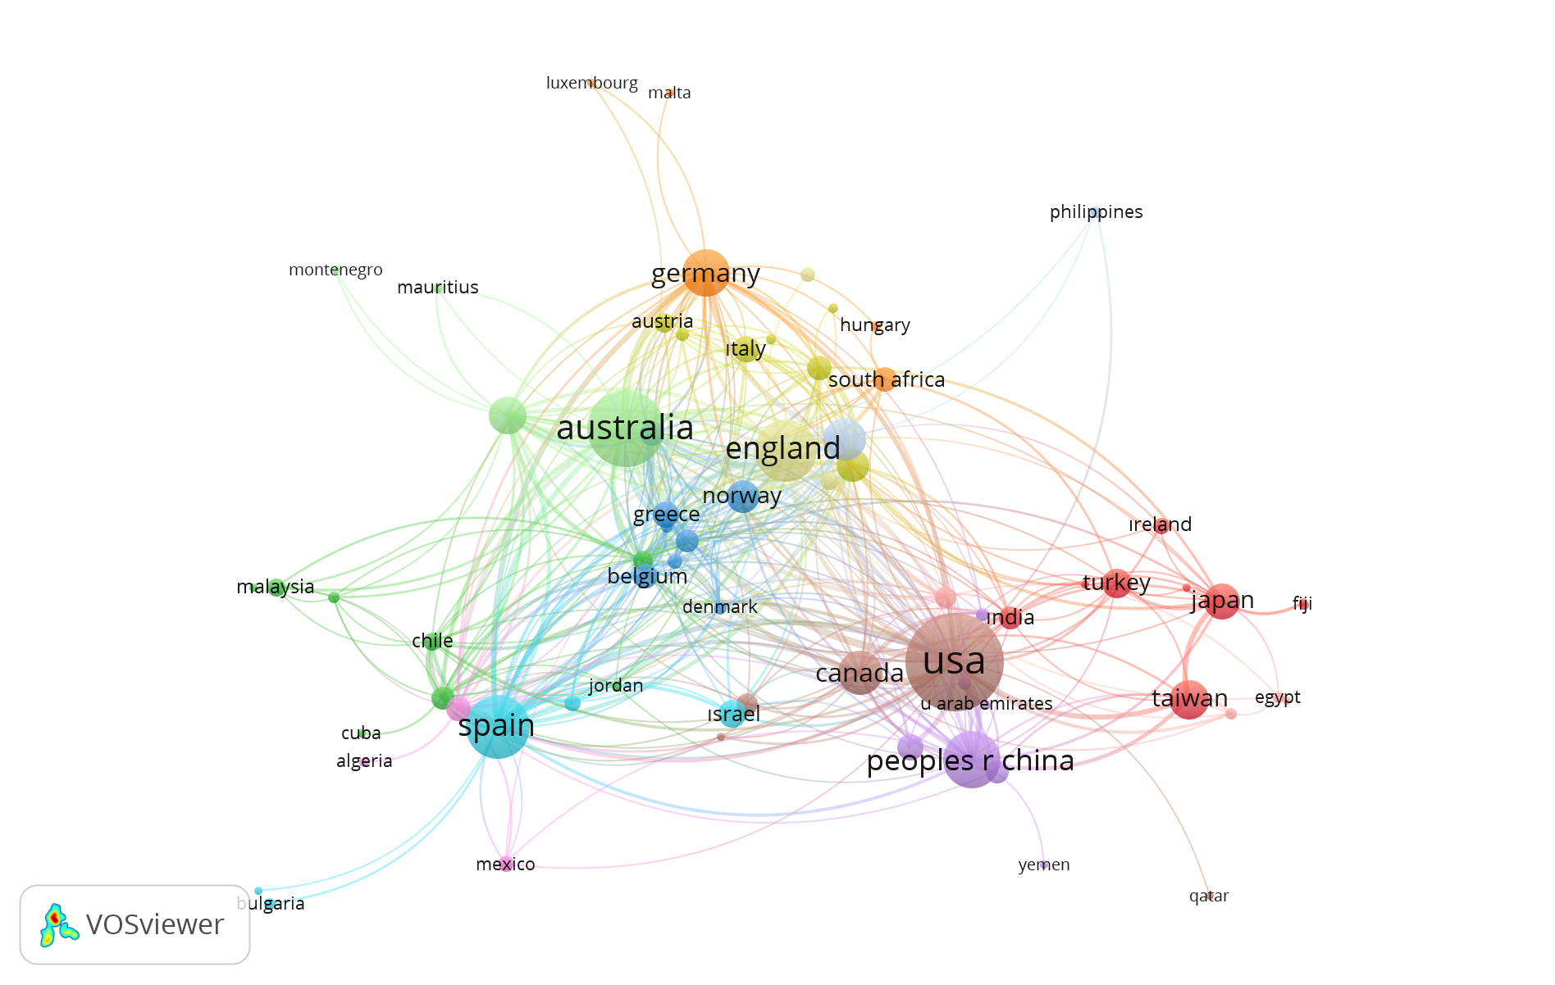

*Figure-4: Co-Authorship By Country Network*

The total number of countries with at least one document and citation is 78. In Figure 4, collaborating countries are divided into 13 clusters, with 413 connection lines among them (when the minimum number of documents and citations of a country is set to 1). The number of connected countries for the USA and Australia is the same (Link = 39). However, in terms of Total Link Strength, Australia (216 connections) is ranked first. Australia is followed by the USA (186 connections), Spain (150 connections), England (122 connections), and Scotland (105 connections). The top five countries in terms of received citations are the USA (5591), Australia (3956), England (3022), Scotland (2005), and Spain (1579).

**Co-authorship by organizations**

When the minimum number of documents and citations of an organization is set to 10, a list of 52 institutions is presented.

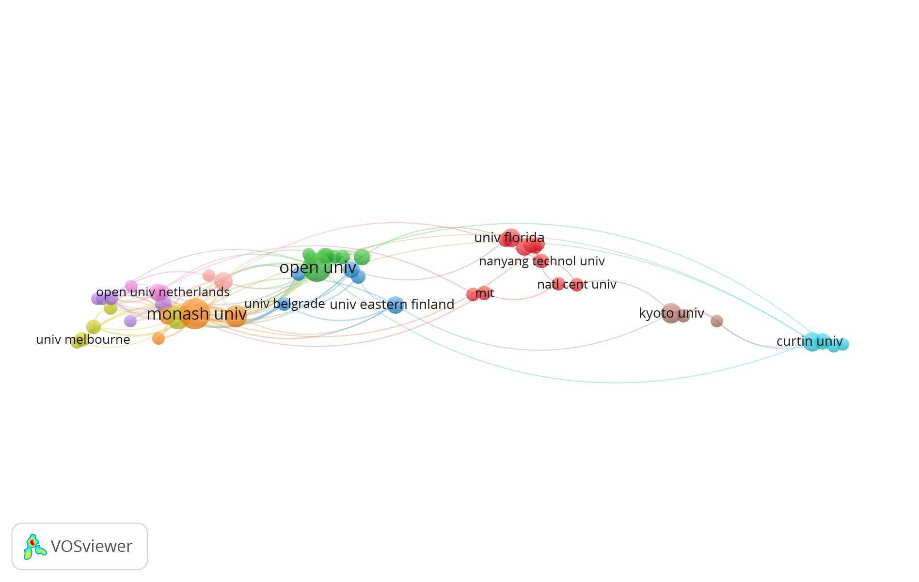

*Figure-5: Co-Authorship By Organizations Network*

In Figure 5, there are 10 clusters and 135 links. When examining the clusters in terms of size, it is noteworthy that the clusters belonging to Monash University and Open University are larger than the other clusters. Additionally, Open University is seen to have a more central position. When it comes to studies related to learning analytics, Open University is one of the most cited organizations, with 1842 citations. When analyzing the figure based on total link strength, Monash University ranks first with a value of 85. It is followed by University of Edinburgh (65), University of South Australia (39), Open University (33), and University of Belgrade (30). Total link strength indicates the number of collaborations between organizations. This figure is a good example that demonstrates document count is not the most influential factor in establishing strong connections and interorganizational collaboration.

In the blue-colored cluster shown in the figure, University of Belgrade and University of Michigan have an equal number of documents (12). However, University of Michigan is not included in the figure because it did not receive sufficient citations. On the other hand, publications from University of Belgrade have 674 citations. Table 2 provides a list of the top 15 organizations that have the most collaboration in the field of learning analytics.

**Table 2.** Organizations with the most collaboration in the field of learning analytics

|  |  |  |  |  |
| --- | --- | --- | --- | --- |
| **Organization** | **Documents** |  | **Citations** | **Total link strength** |
| Monash Univ(Australia) | 58 |  | 780 | 85 |
| University of Edinburgh(Scothland) | 36 |  | 1622 | 65 |
| University of South Australia(Australia) | 32 |  | 898 | 39 |
| Open University(Uk) | 51 |  | 1842 | 33 |
| University of Belgrade(Serbia) | 12 |  | 674 | 30 |
| Tallinn University (Estonia) | 19 |  | 202 | 28 |
| University of Technology Sydney (Australia) | 22 |  | 396 | 27 |
| [Charles III University of Madrid(Spain)](https://www.google.com/url?sa=t&rct=j&q=&esrc=s&source=web&cd=&ved=2ahUKEwi4w4ynhcz8AhXLTKQEHTRMCTsQFnoECEIQAQ&url=https%3A%2F%2Fen.wikipedia.org%2Fwiki%2FCharles_III_University_of_Madrid&usg=AOvVaw1HiuS0-ZYkqT3Wcb7H0-MA) | 18 |  | 327 | 26 |
| University of Sydney(Australia) | 19 |  | 858 | 22 |
| University of Valladolid(Spain) | 13 |  | 252 | 22 |
| Curtin University(Australia) | 23 |  | 308 | 17 |
| Ecole Polytechnique Fed l  Lausanne(Switzerland) | 11 |  | 385 | 15 |
| [University of Mannheim(Germany)](https://www.instagram.com/uni_mannheim/) | 17 |  | 190 | 15 |
| Central China Normal University(China) | 19 |  | 166 | 12 |
| Simon Fraser University(Canada) | 17 |  | 674 | 12 |

**Findings from co-citation analysis**

**Co-reference citation network (Citation sources leading the field)**

The map for the common reference citation network is shown in Figure 6. In the VOSviewer application, the minimum number of citations for a reference to be included in the map is set at 20. Out of 42,610 cited references, 149 meet this threshold. In the mapping, the reference common citation network is divided into 5 clusters: the yellow cluster with 145 authors, the green cluster with 142 authors, the blue cluster with 134 authors, the purple cluster with 132 authors, and the red cluster with 118 authors.

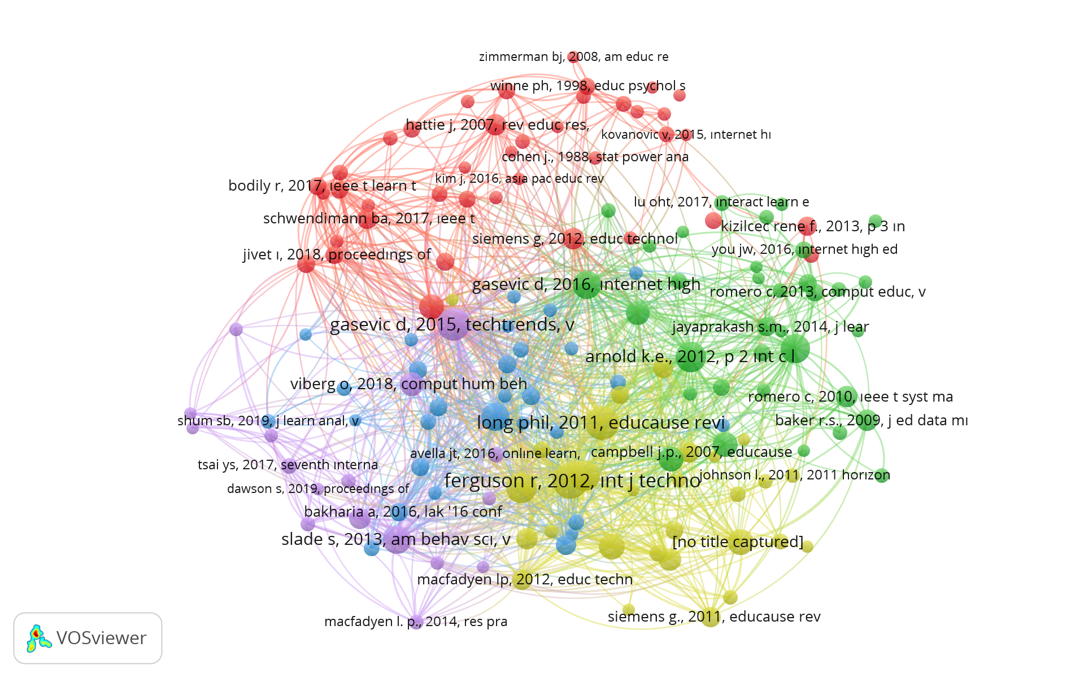

*Figure-6: Co-Cited References Network*

The citation counts of the 10 most commonly cited publications as a result of the common reference citation network analysis are given in Table 3.

**Table 3.** Publications with the highest common citations in the shared reference citation network:

|  |  |  |  |
| --- | --- | --- | --- |
| **Authors** | **Title** | **Journal** | **Citation** |
| Ferguson (2012) | Learning analytics: drivers, developments and challenges. | International Journal of Technology Enhanced Learning | 165 |
| Long and Siemens (2011) | Penetrating the Fog: Analytics in Learning and Education | EDUCAUSE Review | 144 |
| Gašević, Dawson & Siemens (2015) | Let’s not forget: Learning analytics are about learning | TechTrends | 132 |
| Arnold & Pistilli (2012, April). | Course signals at Purdue: using learning analytics to increase student success | Proceedings of the 2nd international conference on learning analytics and knowledge | 116 |
| Greller & Drachsler (2012) | Translating Learning into Numbers: A Generic Framework for Learning Analytics | Educational Technology & Society | 116 |
| Siemens (2013) | Learning Analytics: The  Emergence of a Discipline | American Behavioral Scientist | 116 |
| Macfadyen and Dawson (2010) | Mining LMS data to develop an ‘‘early warning system” for educators: A proof  of concept | Computers & Education | 110 |
| Gasevic et. al. ( 2016) | Learning analytics should not promote one size fits all: The effects of  instructional conditions in predicting academic success | Internet and Higher Education | 101 |
| Lockyer, Heatcote and Dawson (2013) | Informing Pedagogical Action:  Aligning Learning Analytics  With Learning Design | American Behavioral Scientist | 100 |
| Slade and Prinsloo (2013) | Learning Analytics: Ethical  Issues and Dilemmas | American Behavioral Scientist | 98 |

**Citation analysis –sources**

In the Vosviewer analysis program, when the minimum number of documents of a source is set to 5 and the minimum number of citations of a source is set to 0, 57 out of the 215 sources meet the threshold. The network map of the most frequently co-cited journals in the articles is shown in Figure 7.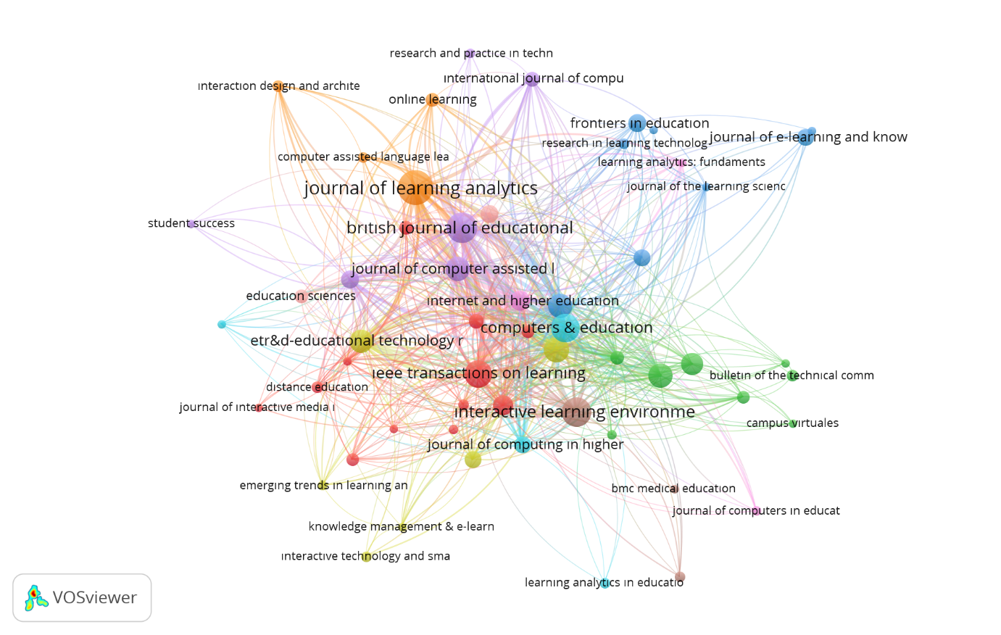

*Figure-7: Citation Analysis By Sources Network*

Figure 7 presents the network analysis of scientific journals cited in the articles produced in the field of learning analytics. It can be observed that the most frequently co-cited journals form a total of 10 clusters, represented by red, green, blue, yellow, purple, turquoise, orange, brown, lilac, and pink clusters. Accordingly, the most cited source in the articles is the journal "Computers and Education," represented by the blue cluster, with a total of 1950 citations. Following this journal, "Educational Technology & Society" in the yellow cluster with 1642 citations and "British Journal of Educational Technology" in the green cluster with 1485 citations are the next most cited journals. The 15 journals with the most co-cited articles are given in Table 4.

**Table 4.** Most frequently co-cited journals in the articles

|  |  |  |  |
| --- | --- | --- | --- |
| **Source(First Issue)** | **Documents** | **Citations** | **Total Link Strength** |
| British Journal of Educatıonal Technology(1970) | 67 | 1485 | 471 |
| Journal of Learnıng Analytics(2014) | 87 | 874 | 462 |
| Educatıonal Technology & Socıety(1998) | 45 | 1642 | 405 |
| Computers & Educatıon(1976) | 59 | 1950 | 380 |
| Internet and Higher Education(1998) | 30 | 1471 | 360 |
| Ieee Transactions on Learnıng Technologies(2008) | 56 | 1052 | 299 |
| Technology Knowledge and Learning(1996) | 42 | 644 | 291 |
| Journal of Computer Assisted Learnıng(1985) | 44 | 1051 | 268 |
| Educational Tchnology Research and Development(1953) | 40 | 439 | 211 |
| International Journal of Technology Enhanced Learning(2008) | 15 | 914 | 203 |
| Interactive Learning Environments(1990) | 61 | 640 | 196 |
| Techtrends(1985) | 17 | 550 | 182 |
| Australasian Journal of Educational Technology(1985) | 24 | 255 | 161 |
| Education and Information Technologies(1996) | 44 | 348 | 140 |
| Journal of Computing ın Higher Education(1989) | 22 | 225 | 127 |

According to Table 4, the majority of the journals included in the list are established magazines that started their publication before the year 2000. However, in terms of total link strength, the second-ranked journal, Journal of Learning Analytics, is observed to have started its publication in 2014. Considering that this journal continues its publication specifically in the field of learning analytics, it can be stated that it contributes to the development and advancement of the field. Additionally, this journal is the one with the highest number of published articles in the field.

**Keyword Analysis**

Among a total of 3063 keywords, when the threshold value is set to 10 as the minimum number of occurrences of a keyword, 64 keywords meet this threshold value. Figure 7 shows the network map of the most frequently used keywords in the field of learning analytics. There are 9 different clusters represented by colors: red, blue, yellow, green, orange, purple, turquoise, brown, and pink. Keywords branching within the same color indicate the highest co-occurrence rate among keywords. Therefore, these keywords may be more closely related to each other. The thickness of the connections between circles increases based on the frequency of co-occurrence of the keywords written inside the circles. The size of the circles is related to the occurrence count of the keyword. The red cluster represents the closely related and most frequently used concepts such as adaptive learning, artificial intelligence, computational thinking, e-learning, game-based learning, learning analytics, mobile learning, personalization, personalized learning, precision education, student engagement, technology-enhanced learning, and technology-enhanced learning. The blue cluster represents the closely related and most frequently used concepts such as analytics, blended learning, educational technology, feedback, flipped classroom, higher education, learning, learning strategies, self-regulated learning, and teaching.

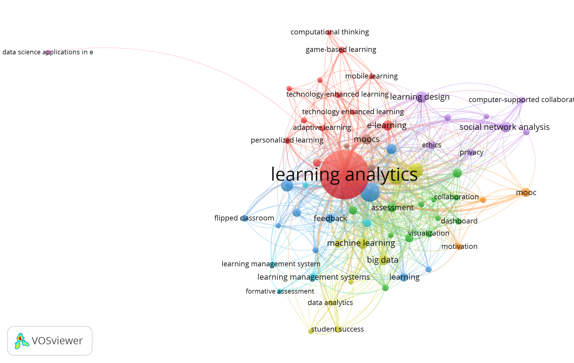

*Figure-8: Co-word Network*

When examining the figure, it is natural that the most frequently mentioned keyword is "learning analytics." In terms of both total link strength and occurrence, "higher education" is in the second position. Therefore, it can be said that learning analytics is predominantly used in the context of higher education, indicating that research in this field is primarily conducted at that level. The third most commonly used keyword is "educational data mining."

The most frequently used 25 keywords are listed in Table 4. The Total Link Strength (TLS) value in Table 5 indicates the number of connections a keyword has with other keywords.

**Table 5.** Social network analysis of keywords used in scientific publications related to learning analytics

|  |  |  |
| --- | --- | --- |
| **Keyword** | **Occurrences** | **Total link strength** |
| learning analytics | 813 | 977 |
| higher education | 126 | 207 |
| educational data mining | 91 | 158 |
| online learning | 73 | 147 |
| learning design | 46 | 87 |
| self-regulated learning | 50 | 80 |
| big data | 39 | 79 |
| machine learning | 40 | 79 |
| moocs | 38 | 72 |
| social network analysis | 39 | 71 |
| blended learning | 36 | 69 |
| e-learning | 37 | 65 |
| collaborative learning | 29 | 59 |
| assessment | 29 | 56 |
| education | 24 | 53 |
| feedback | 30 | 53 |
| engagement | 24 | 45 |
| learning management systems | 23 | 44 |
| distance education | 21 | 42 |
| data mining | 26 | 40 |
| ethics | 21 | 39 |
| visualization | 18 | 39 |
| collaboration | 14 | 38 |
| distance learning | 18 | 37 |

When examining Table 5, it can be observed that MOOCs (38) have more occurrences in learning analytics studies compared to LMS (23), indicating that they are more extensively explored. One possible reason for this could be that MOOCs serve not only formal but also informal learning contexts.

Given that learning analytics is related to data in virtual learning environments, it is natural that some prominent keywords include "online learning" and "e-learning," which represent learning contexts.

Figure 9 depicts the usage intensity of the most commonly used keywords in learning analytics studies over the years. This figure is important as it provides a clear indication of the current research topics in the field.

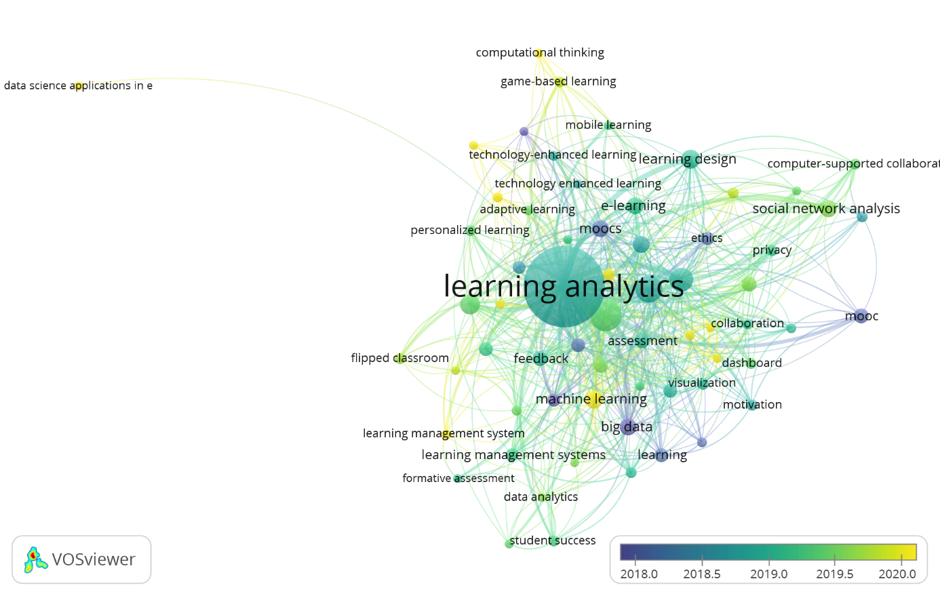

*Figure 9: Network showing the distribution of keywords over the years*

In the figure, a scale ranging from dark blue to yellow can be observed. It can be seen that topics such as big data, MOOCs, MOOCs, ethics, and personalization were among the earlier research keywords in the clusters represented by dark blue, while keywords such as data science applications in education, course design, learning management system, precision education, computational thinking, artificial intelligence, task analysis, and tool are more recent and belong to the yellow cluster. Based on this, it can be inferred that in recent years, there has been a focus on learning analytics related to learning management systems (LMS) rather than MOOCs as learning environments.

**Discussion and Conclusion**

This study evaluates the general state of articles published in the literature on learning analytics through visualizations. Although some studies have been conducted on research in the field of learning analytics, a comprehensive analysis study aiming to examine the effective journals, countries, organizations and resources in the field, as well as providing a dynamic depiction of the field through analytical tools, has not been conducted to date. This study presents data and inferences regarding the relationships among authors, countries, and institutions collaborating in the field, influential studies shaping the field, journals, and related subtopics of the field.

When examining the distribution of studies related to learning analytics according to publication years, it is observed that the field has been studied since 2011. This data indicates that learning analytics is a new field that emerged as a result of the need for assessments regarding students with the proliferation of online learning environments. Furthermore, it can be seen that studies reached their peak in 2020 due to the worldwide shift towards remote education following the COVID-19 pandemic since December 2019.

In terms of common authorship analysis by countries, the results show that although the United States ranks first in terms of document count and citations , Australia has a stronger network structure. Therefore, it can be said that researchers affiliated with institutions in Australia engage more in teamwork and collaboration. Thus, it can be inferred that Australia has larger-scale projects and studies with a greater impact in the field of learning analytics. Various review studies in the literature confirm the notable position of Australia in research and applications focusing on learning analytics (Ifanthaler et al., 2021; Valenzuela et al., 2021).

When examining the leading citation sources that shape the field, the article "Learning Analytics: Drivers, Developments, and Challenges" by Ferguson (2012) ranks first. Ferguson (2012) emphasizes in this study that the needs and developments in the emergence of the concept of learning analytics. In addition, the future of the field and some concerns are discussed in detail in the study. The study deserves the credit it receives because it covers the connection between the past and the future of the field so comprehensively.

The top 3 most cited journals in the articles are Computers and Education (1950), Educational Technology & Society (1642), and British Journal of Educational Technology (1485). These journals are known to be prestigious journals in the field of educational technologies. Therefore, it can be said that these mentioned journals have played an influential role in shaping the intellectual background of the learning analytics field.

In keyword analysis, it is observed that the first keyword that stands out after learning analytics is "higher education." This data indicates that learning analytics is predominantly used for undergraduate students. This finding is supported by several other studies that compile research and conduct descriptive statistics on learning analytics (Çetinav and Yılmaz, 2021; Gülcüoğlu et al., 2021).

When examining the most frequently used keywords in learning analytics research, "higher education" is followed by "educational data mining." Learning analytics (LA) is closely related to the field of educational data mining (EDM) and involves the measurement, collection, analysis, and reporting of data about learners and their contexts with the aim of understanding and optimizing learning and the environments in which it occurs (Long and Siemens, 2011). Both learning analytics and educational data mining aim to gather data, measure, analyze, and report on how learners learn. Therefore, they both progress toward the same goal (Peña-Ayala, 2014). Koedinger et al. (2015) emphasize that learning analytics and educational data mining share a common goal, which is to enable data-informed decisions regarding learning-teaching processes. However, Ferguson (2012) points out that despite sharing a common goal, there is a distinct point that sets these two contemporary research domains apart. According to Ferguson (2012), while educational data mining has a technical focus, learning analytics has an educational focus.

When the frequency and intensity of keywords are considered together, although there are more publications related to MOOCs than LMSs in learning analytics research, there is a shift towards LMSs from MOOCs towards the present. This can be attributed to the impact of the COVID-19 pandemic that we left behind in the past. During the periods when all schools were temporarily closed, education continued remotely. Therefore, the increased awareness level regarding mobile LMSs used for formal education during this period (Habibi et al., 2023) can be accepted as the source of this shift.

It is hoped that this research on learning analytics will be a bedside resource for researchers who are newly interested in this field. When researchers examine the findings of this study, they can gain insights about the research topics that are needed, influential researchers shaping the field, essential resources to refer to, supporting and hosting institutions in the field, journals, and countries.

**References**

Arnold, K. E., & Pistilli, M. D. (2012, April). Course signals at Purdue: Using learning analytics to increase student success. In *Proceedings of the 2nd international conference on learning analytics and knowledge* (pp. 267-270).

Çetintav, G. ve Karaoğlan Yılmaz, F.G. (2021). Öğrenme analitikleri ve öz-düzenlemeli öğrenme üzerine araştırma eğilimlerinin incelenmesi: Sistematik bir inceleme. *Amasya Üniversitesi Eğitim Fakültesi Dergisi*, 10(2), 80-95. DOI: 10.17539/amauefd.1036352

Dawson, S., Gašević, D., Siemens, G., & Joksimovic, S. (2014). Current State and Future Trends: A Citation Network Analysis of the Learning Analytics Field. In *Proceedings of the Fourth International Conference on Learning Analytics And Knowledge (pp. 231–240)*. New York, NY, USA: ACM. doi:10.1145/2567574.2567585

Ferguson, R. (2012). Learning analytics: Drivers, developments and challenges. *International Journal of Technology Enhanced Learning,* 4(5/6), 304–317, 2012.

Freeman, L.C. (2004). The development of social network analysis: A study in the sociology of science. Vancouver: Empirical Press.

Gašević, D., Dawson, S., & Siemens, G. (2015). Let’s not forget: Learning analytics are about learning. *TechTrends*, *59*(1), 64-71.

Gašević, D., Dawson, S., Rogers, T., & Gasevic, D. (2016). Learning analytics should not promote one size fits all: The effects of instructional conditions in predicting academic success. *The Internet and Higher Education*, *28*, 68-84.

Greller, W., & Drachsler, H. (2012). Translating Learning into Numbers: A Generic Framework for Learning Analytics. *Educational Technology & Society*, *15* (3), 42–57.

Gülcüoğlu, E., Karaoğlan Yılmaz, F. G., Gökkaya, G. (2021). Öğrenme analitikleri kapsamında 2016-2019 yıllar arasında Web of Science veritabanında yayınlanan makalelerin betimsel analizi. *Bilgi ve İletişim Teknolojileri Dergisi,* 3(1), 42-76.

Habibi, A., Yaakob, M. F. M., & Al-Adwan, A. S. (2023). m-Learning management system use during Covid-19. *Information Development*, *39*(1), 123-135.

Ifenthaler, D., Gibson, D., Prasse, D., Shimada, A., & Yamada, M. (2021). Putting learning back into learning analytics: Actions for policy makers, researchers, and practitioners. *Educational Technology Research and Development,* 69, 2131–2150. .https://doi.org/10.1007/s11423-020- 09909-8

Kıcıman vd. (2021). 2016-2020 yılları arasında öğrenme analitiği ile ilgili yapılmış SSCI indeksli makalelerin sistematik olarak incelenmesi. *Instructional Technology and Lifelong Learning,* 3(1). 135-152. DOI: 10.52911/itall.875685.

Long, C., & Siemens, G. (2011, September 12). Penetrating the fog: Analytics in learning and education. *EDUCAUSE Review, 46*(5). <http://er.educause.edu/articles/2011/9/penetrating-the-fog-analytics-in-learning-and-education>

Koedinger, K. R., D’Mello, S., Mclaughlin, E. A., Pardos, Z. A., & Rosé, C. P. (2015). Data mining and education. *Wiley Interdisciplinary Reviews: Cognitive Science,* 6(4). <http://doi.org/10.1002/wcs.1350>

Macfadyen, L. P., & Dawson, S. (2010). Mining LMS data to develop an “early warning system” for educators: A proof of concept. *Computers & Education*, *54*(2), 588-599.

Papamitsiou, Z., & Economides, A. A. (2016). Learning analytics for smart learning environments: A meta-analysis of empirical research results from 2009 to 2015. *Learning, design, and technology: An international compendium of theory, research, practice, and policy*, *1*, 23.

Peña-Ayala, A. (2014). Educationaldatamining: A surveyand a data miningbasedanalysis of recentworks. *Expert Systems with Applications*, 41(4-1), 1432- 1462.

Pritchard, A. (1969). Statistical bibliography or bibliometrics. *Journal of Documentation,* 25(4), 348-349.

Rehn, C., Gornıtzkı, C., Larsson, A., & Wadskog, D. (2014). Bibliometric Handbook 2.0 (2014). *Annu Rev Med*, *57*, 119-37.

Siemens, G., & Baker, R. S. J. d. (2012). Learning Analytics and Educational Data Mining: 158 Torwards Communication and Collaboration. *Proceedings of the 2nd International Conference on Learning Analytics and Knowledge - LAK ’12*, 252–254. <http://doi.org/10.1145/2330601.2330661>

Wong, B. T. M. (2017). Learning analytics in higher education: an analysis of case studies. *Asian Association of Open Universities Journal*.

Wong, B. T. M., Li, K. C., & Choi, S. P. M. (2018). Trends in learning analytics practices: A review of higher education institutions. *Interactive Technology and Smart Education*.

Valenzuela, C. G., González, C. G., Rojas, A., & Tagle, M. (2021). Learning analytics in higher education : a preponderance of analytics but very little learning ? *International Journal of Educational Technology in Higher Education,* 18(1), 1-19. https://doi.org/10.1186/s41239-021- 00258-x

Van Eck, N. J. & Waltman, L. (2010). Software survey: Vosviewer, a computer program for bibliometric mapping. *Scientometrics*, 84, 523–538.

Zhu, M., Sari, A. R., & Lee, M. M. (2022). Trends and issues in mooc learning analytics empirical research: A systematic literature review (2011–2021). *Education and Information Technologies*, *27*(7), 10135-10160.

*This article is an expanded version of the virtual presentation presented in International Conference on Humanities, Education, and Social Sciences*