**A Study on the Perceptions of EFL Students towards Using the Cambridge Unlock Classroom App**

**Mohammad Zaid, Suzan Shehada**

|  |  |  |
| --- | --- | --- |
| **Article Info** |  | **Abstract** |
| ***Article History***  Received:  01 Month Year  Accepted:  01 Month Year |  | This paper deals with the importance of integrating Cambridge Classroom App in the classroom. The researchers based the idea of the study upon the newly published second edition of Unlock Series titled Reading, Writing, and Critical Thinking alongside Listening and Speaking and Critical thinking. Side by side with the online Cambridge accounts, students should download a mobile application known as “Cambridge Pocket”, which is easily accessible by students via App store and Android systems. In fact, this paper aims at analysing the attitudes of Birzeit University students towards the integrated mobile application within their English language curriculum (Cambridge Unlock). It precisely reveals important findings concerning how responsively, emotionally, motivationally and educationally this application works. All such hypotheses and questions have been clarified quantitatively and qualitatively. To achieve this purpose, 120 students were randomly selected from Unlock B1.2., Intermediate English and given a questionnaire. Concerning the qualitative data, it has been sought by analysing students’ responses to a set of open-ended questions within the questionnaire in order to reflect on their experience with the second edition of Unlock Books. Hence, this research shows the importance of integrating such apps within the English language classroom. |
| ***Keywords***  Cambridge  Mobile Apps  Motivation  Learning Skills |  |

**Introduction**

Currently, technology has invaded every sphere of human life. Thanks to globalization, the integration of technology has created a shift in the way the world functions. People live in an automated world, highly enriched with new enhancement and development at all levels. Technology has filled every home with new devices that have a multitude of functions. One such reflection of this technological era is the introduction of mobile devices as a tool for teaching and learning. According to Baradaran & Kharazyan (2016), the use of technology in education is increasing.

The integration of such devices would create a hybrid atmosphere in the classroom, giving more space to students who are more inclined to learn through technology. Accordingly, Sharples et al. (2005) point out that technological devices create an interactive classroom where students engage in activities interestingly and knowingly; in other words, students are no longer only receivers of information, rather they are productive and partners in the entire learning process. Cui and Wang (2008) indicate that mobile devices have been enhanced and improved to the extent that they stand alongside computers in their capacity, efficiency, and functionality.

According to (Gay et al, 2001) the use of mobiles is supplementary and subsidiary to other learning tools and thus would not replace other existing modes of learning. Other researchers indicate the value of mobiles as easily accessible and spatially present with students (Chinnery, 2006; Rosell-Aguilar, 2007)

The researcher of the present study developed this hypothesis based upon data from Birzeit University. Birzeit’s Department of Languages and Translation has adopted a Cambridge book series (Unlock) that targets English communication skills. This book is supported by LMS Cambridge accounts, where students have access to online material supplementary to the book’s content. Online-based questions vary among the four skills—reading, writing, listening, and speaking—and video clips are structured around each intended unit. Birzeit University has also adopted the newly published edition of the Unlock Series titled *Reading, Writing, & Critical Thinking*, alongside *Listening, Speaking & Critical Thinking*. In conjunction with the online Cambridge accounts, students should download a mobile application called Cambridge Pocket, which is easily accessible through the App Store and Android.

This paper aims to analyze the attitudes of students who have integrated this mobile-centered application, specifically examining how this application works responsively, emotionally, motivationally and educationally. Does the use of such apps really improve the four literacy skills for students? Does it help to increase students’ motivation and learning? All such hypotheses and questions are intended to be clarified quantitatively and qualitatively. The researchers have adapted a questionnaire from Rebeca Idris & Sylvia Iskounen (2008), who have conducted similar research under the People’s Democratic Republic of Algeria Ministry of Higher Education and Scientific Research to assess mobile-assisted learning. The other qualitative data is sought by analyzing students’ responses to a set of open-ended questions within the questionnaire to reflect on their experience with the new edition of the Unlock book series. Hence, this research will support and enhance the importance of integrating those apps within the classroom should this hypothesis prove significant.

**Literature Review**

*Learning ESL Vocabulary with Smartphones* by (Wu, 2014) investigated the efficiency of smartphones in assisting ESL college students in learning English vocabulary. 50 students were evenly separated into a control group and an experimental group. A pre-test and post-test were administered to assess the impact. The study discovered that the students in the experimental group did better than those in the control group. This paper also aimed to establish a research design or set up an educational example, which might be followed.

*The Effect of Mobile Applications on English Vocabulary Acquisition* (Rezaei et al., 2014) investigated the use and effectiveness of mobile applications in English vocabulary learning. Vocabulary acquisition is a significant part of language learning. This research studies intermediate learners’ performance before and after using mobile applications. The use of these applications was presented to the study group as an intervention. The study examined if multimedia courseware affected vocabulary learning in second language achievement. The data indicated a positive change in learners’ performance, and the questionnaire analysis indicated that using mobile applications helped improve vocabulary acquisition, self-confidence, and class input. The results also showed that students had a strong tendency to use multimedia in education.

*Effectiveness of Mobile Applications in Vocabulary Teaching* was completed by (Basal et al., 2016) at Yildiz Technical University, Turkey. This 4-week study intended to examine the efficiency of a mobile application on teaching 40 idioms from the Michigan Corpus of Academic Spoken English (MICASE) compared to teaching through usual activities. A pre-test and post-test were employed to find out the differences between the scores of the control and experimental groups, shaped with convenience sampling. The results indicated that the participants in the experimental group performed better in the post-test, representing the effectiveness of using mobile applications to learn idioms. This study gave recommendations towards the use of mobile applications in vocabulary teaching.

Other researchers have investigated the validity of mobiles in developing the listening skills for students. *Emerging Mobile Apps to Improve English Listening Skills* by Kim (2013) investigated the effects of Mobile-Assisted Language Learning (MALL) in listening skills. This study examined whether participants developed their listening skills after taking an English course for one semester in college. It also examined if there were significant differences in listening skills between the control group without mobile apps and the experimental group with mobile apps. Additionally, it investigated students’ opinions towards using mobiles to improve their listening abilities. The results presented data that indicates how MALL practice can improve listening skills. The study suggested educational implications for future research.

In a similar study titled “*The Role of a Mobile App for Listening Comprehension Training in Distance Learning to Sustain Student Motivation*,” (Read & Kukulska-Hulme, 2015) investigated the importance of listening comprehension for language students. They discussed the benefits of using a mobile app to encourage its practice and improvement. They specifically examined the use of “The Audio News Trainer” (ANT). In the experiment, data was gained through interaction with the app and pre- and post-questionnaires. Based on initial studies, this data appears to support the use of ANT to motivate the extended practice of listening comprehension and the significance of social media-based interaction in second language learning.

In addition, other scholars have talked about utilizing mobiles apps in developing reading skills. *Effectiveness of mobile learning application in improving reading skills in Chinese language and towards post-attitudes* is quasi-experimental research conducted to investigate the effects of smartphone applications on Chinese language reading skills. This study also examined students’ perceptions of the use of smartphone applications. Data was collected on 53 students based on oral pre- and post-tests. A 4-point Likert scale questionnaire was also used. A Mann-Whitney U test was employed to investigate whether there was a significant difference between the control and experimental groups. The results showed that students demonstrated higher test scores after four weeks of intercession. Students found it easier and preferable to learn reading skills with the use of smartphone applications compared to traditional methods, according to (Chee et al., 2017). Scholars have also considered teaching writing through mobiles*. The Effect of "WhatsApp" Electronic Dialogue Journaling on Improving Writing Vocabulary Word Choice and Voice of EFL Undergraduate Saudi Students* was conducted by (Alsaleem, 2013). This study attempted to determine whether WhatsApp as an application in smartphones had a major effect on the writing vocabulary of Saudi undergraduate students. The study was a quasi-experimental study, in which data was collected using a pre-test and post-test. The sample included 30 EFL undergraduate female students in Languages and Translation College at AlImam Mohammad Ibn Saud Islamic University in Saudi Arabia. The significance of the study was measured using the Kruskal-Wallis, Friedman, and Wilcoxon tests. Results indicated a considerable difference between the writing scores of the pre-tests and post-tests of the students that journaled. Examination of individual item scores revealed remarkable improvements in vocabulary word choice and voice as two critically important writing factors.

*Maximizing L2 Speaking Practice through iPads* by Theresa Schenker and Angelika Kraemer, used a simple iPad application to investigate the effects of additional speaking practice on students’ speaking ability, fluency, and syntactic complexity. The experimental and control groups (N = 52) fulfilled an Oral Proficiency Interview (SOPI) at the end of the semester. Results of a t-test discovered statistical differences between both groups. Students who received extra speaking practice on iPads achieved higher scores than students in the control group. Results did not show any statistical differences between the two groups for fluency and complexity.

*Categorizing Educational Applications of Mobile Technologies into Four Types* (Park, 2011) is another study that compared mobile learning with electronic learning and ubiquitous learning (u learning) and described the scientific aspects of mobile learning presented in previous studies. A transactional distance (TD) theory was modified and adopted as a theoretical framework for mobile learning in distance education. This study tried to place previous studies into four types of mobile learning: 1) high transactional distance socialized m-learning, 2) high transactional distance individualized m-learning, 3) low transactional distance socialized m-learning, and 4) low transactional distance individualized m-learning. (Park, 2011). These results can be used by those who work in instructional design to learn about the insights of mobile education and how mobile technology can be implemented successfully in teaching and learning.

(Rosell-Aguilar, 2016) reviewed current research on the impotence of apps for language education. It presented a classification of apps and their use for language learning. Additionally, the article developed a structure consisting of four categories for evaluating language learning apps (technology, pedagogy, user experience, and language learning). It also included a set of principles within each of the categories.

*The Impact of Mobile Dictionary Use on Language Learning* by (Rahimi & Miri, 2014)investigated the effect of using a mobile dictionary on language learning. Thirty-four language learners participated in a pretest-posttest quasi-experimental study. Participants were divided into two equal groups. The experimental group used a dictionary on their mobile phones to perform their activities, whereas the control group worked with the printed edition of the same dictionary. The results showed that the experimental group outperformed the control group in the post-test while controlling for the entry-level language ability. The study’s findings highlighted the vital role that mobile phones play in expanding learning outside of the classroom.

*Tablets for informal language learning: student usage and attitudes* by (Chen, 2013) investigated how students used tablet computers to study English in informal settings outside their classes and how to promote efficient usage of the tablet for independent language learning. The study demonstrated that tablet computers are perfect tools for creating an interactive and omnipresent environment for language learning. This research also revealed that students have a positive attitude towards the usability, usefulness, and fulfilment of tablet computers for Mobile Assisted Language Learning.

**Method**

This research uses both a quantitative and qualitative approach to analyze data. It deals with the validity and importance of Cambridge Mobile Apps and whether they contribute to the learning and teaching process. To achieve this purpose, 120 students were randomly selected from Unlock B1.2. English Communication 2202 is a two-credit hour course that integrates the four language skills. In this course, students should be able to understand the main points of clear standard input on familiar matters regularly encountered: produce a simple connected text on topics that are familiar or of personal interest, develop their abilities to think critically in an academic context, build an argument and counter-argument, describe experiences, events, dreams, hopes and ambitions, and briefly give reasons and explanations for opinions and plans (see <http://www.birzeit.edu/en>). Students were given a four-part questionnaire adapted from *Investigating the Impact of Using Mobile Technology on Improving EFL Students’ Learning Achievement: A Case Study.* Hence, the content and organization of items were adapted to meet the purpose required.

The questionnaire utilized follows the 5-Point Likert Scale to see how students respond to the use of Cambridge apps in the classroom: Strongly Agree, Agree, Neutral, Disagree, and Strongly Disagree. The data was obtained via Google Forms, a free online tool from Google that permits users to create forms and surveys to edit and share with other people. The open-ended responses in the questionnaire were analyzed via this thematic analysis. A thematic analysis looks across all the data to recognize the common issues that reappear and identifies the main themes that summarize all the collected views (Patton & Cochran, p. 23). Thematic analysis is a technique for recognizing, analyzing, and reporting themes in data (Braun & Clarke, 2006). Moreover, “a theme captures something important about the data in relation to the research question and represents some level of patterned response or meaning within the data set” (Braun & Clarke, 2006).

**The Population of the Study**

This study targets 120 students from Birzeit University in Palestine, specifically students who take the mandatory English communication courses using the Unlock book series.

**Results and Discussion:**

To answer the first research question about students’ perceptions towards the use of mobile apps in learning English at Birzeit University, students were asked about the different ways in which they prefer to study.

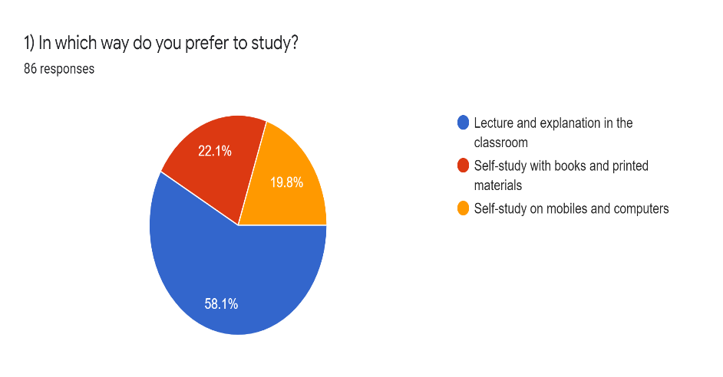

Figure 1

According to the abovementioned figure 1, it is clear that there is a tendency towards being in the classroom for learning (58.1%) compared to the self-study approach regarding using books and mobiles for learning. These results are not surprising, as the students prefer traditional learning in a teacher-centered learning environment. Thus, introducing the new mobile app would help encourage learners in a student-centered learning environment, where the teacher is only a facilitator. Despite students’ interest in using their PCs as a learning tool, this program is easily accessible on both PCs and mobiles (via Cambridge LMS).

To answer the second research question about students’ perceptions towards the effectiveness of the Cambridge classroom app in learning the four language skills at Birzeit University, one can consider how different apps were primarily utilized for vocabulary building along with dictionaries, according to students’ responses to the questionnaire, as clarified in the following figure:

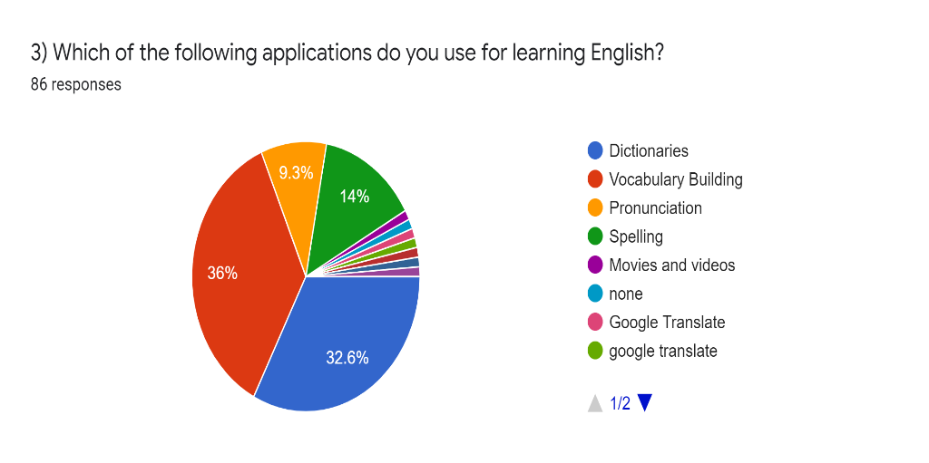

Figure 2

They also showed less focus on speaking-oriented apps, in addition to movies and videos. Indeed, this lack of interest in audio visuals can be tackled by an active implementation of the Cambridge mobile app because it activates such important skills. According to the data, it is clear that students are inclined to learn listening compared to other skills. More than half of the students (54%) supported using the Cambridge classroom app, mainly focusing on listening skills (See figure 3).

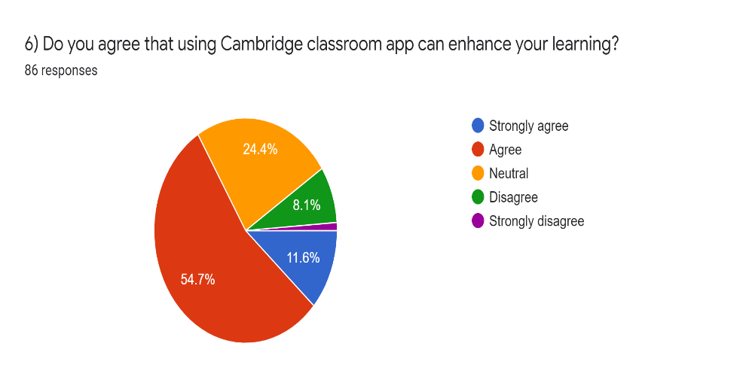

Figure 3

Additionally, according to figure 4 listed below, 44% of students (less than three-quarters of students) agreed that it enhanced their vocabulary, while 4 in 10 expressed the importance of such apps in enhancing listening.

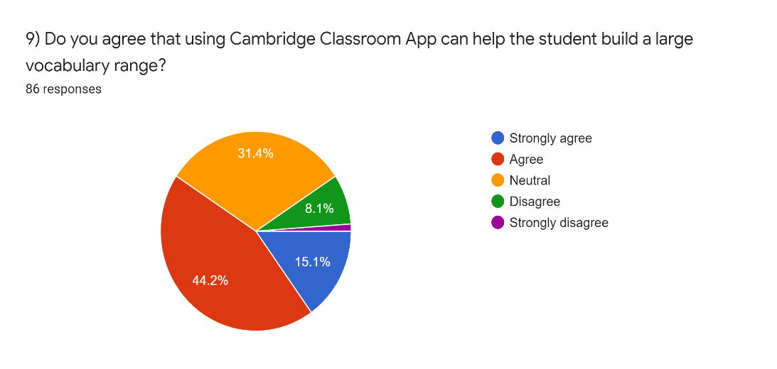

Figure 4

Moreover, 40.7% (two-fifths) of the students thought using the Cambridge Classroom App (CCA) could enhance speaking. (see Figure 5 below).

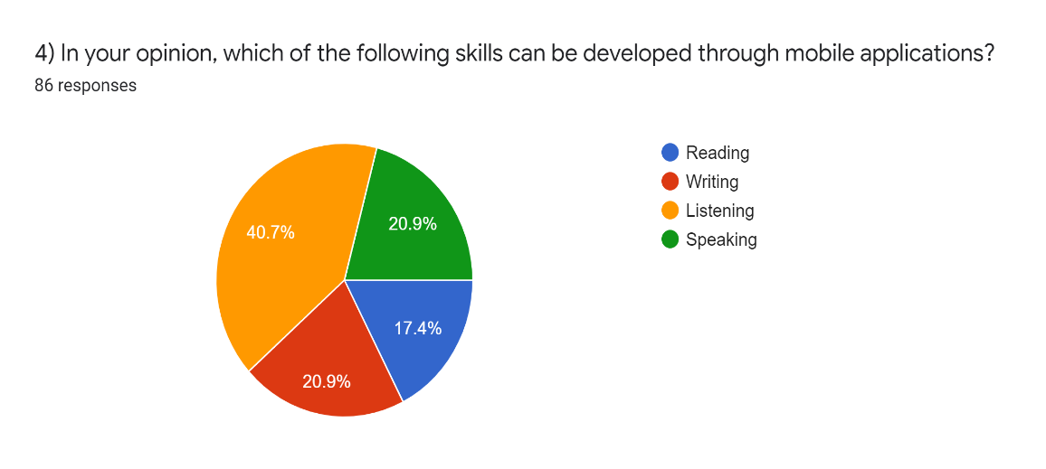

Figure 5

However, some expressed a negative attitude towards speaking (17.4%), as clarified below in figure 6.

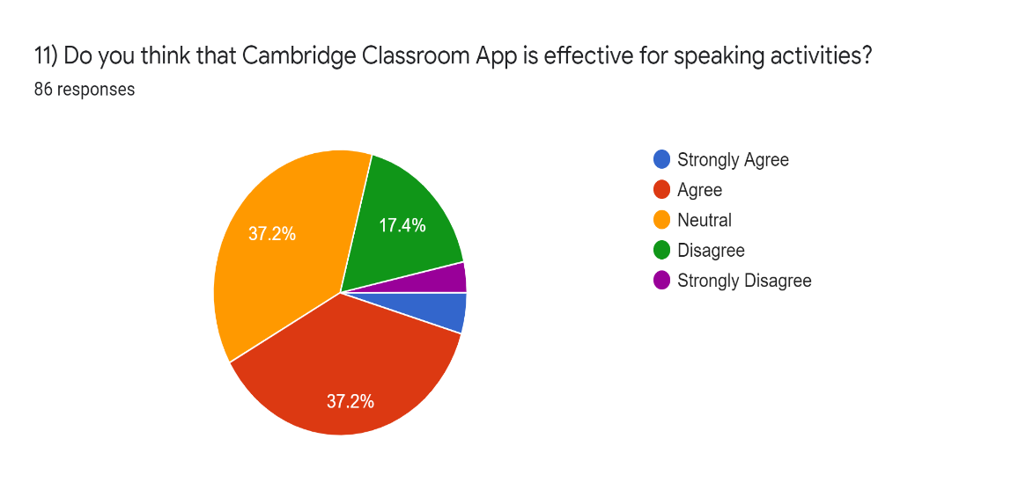

Figure 6

They also lacked practice in such audio-visual skills. In terms of writing, two-fifths of the students showed a tendency to improve their writing skills through the use of CCA. As for the reading skills, 58.1% of students expressed their interest in using CCA for learning reading.(see figure 7 below).

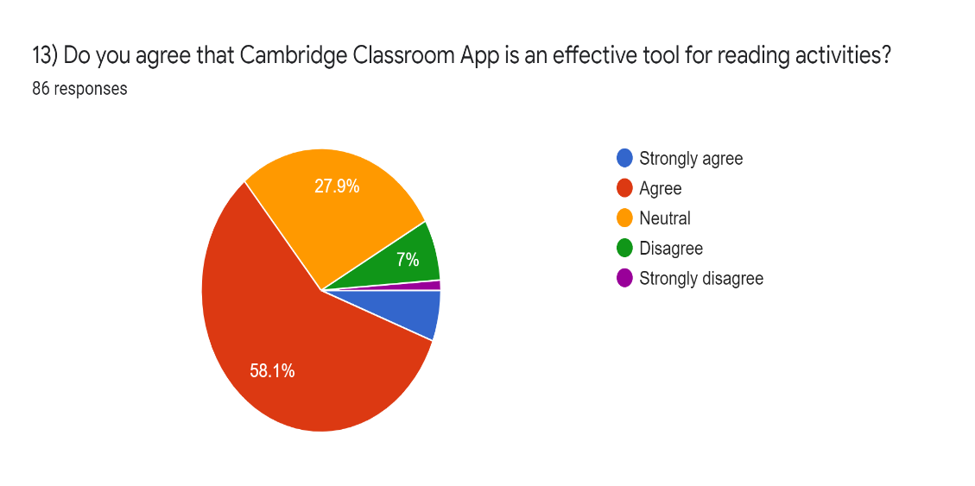

Figure 7

Looking into the open-ended question, which tackled the importance of utilizing the Cambridge classroom app in developing the four language skills, one can notice the students’ positive attitudes towards using mobile apps in general and the Cambridge classroom app in specific. There were approximately eighty written responses. These responses were thoroughly reviewed and analyzed by the researchers via thematic analysis. To be more specific, the researchers found that ten responses were in favor of speaking skills and other corresponding skills, like pronunciation. Similarly, twelve responses were in favor of reading skills and eleven responses were aimed at the importance of writing skills. However, fifteen responses were targeted towards the importance of listening skills; this was the highest number. These responses prove the importance of implementing the CCA in the teaching and learning processes. There were four major themes according to the data, which has been analyzed via the open-ended responses.

**Analysis of Interviews**

As mentioned earlier, ten students expressed a very positive attitude towards utilizing the Cambridge classroom app in learning and how it specifically improved their speaking skills. As one student indicated, “it improves the way of pronouncing and speaking the language.” Another student reported that there are “many applications that provide the opportunity to talk with a virtual partner, which helped me a lot in learning English.” A different student stated that it is essential for “acquisition of accent.” Additionally, some of the responses focused on the importance of pronunciation as an essential element of speaking, stating that “the way the language is pronounced through these applications, learning applications for instance, the things that I couldn't achieve with reading books.” Some students also added that it helped in the “acquisition of accent skill.” This means that it helped improve their accent, which is a vital component of speaking skill.

Students expressed a very positive attitude towards utilizing the Cambridge classroom app in reading comprehension. Namely, twelve students stressed the importance of this skill. As one student reported, “it is important for reading, it adds a lot of meanings to your vocabulary.” According to a different response, “the reading skill can be developed by reading the texts and messages, reading the instructions of how we can use the apps.” Another student reported: “In my opinion, English language skills such as reading, and others are personal skills that can be developed, learned and progressed.”

Eleven students stressed the importance of the Cambridge classroom app in developing writing skills. Several students also indicated how this app is important in teaching them spelling as an essential part of writing skills. “Using mobile application develops the writing skills,” as one student indicated. Similarly, a different student said, “you can learn how to spell words.” The different responses supported the importance of such apps as a crucial aid in the learning process.

Approximately fifteen responses supported the importance of utilizing the Cambridge classroom app in developing listening skills. In this regard, one student stated that “using mobiles and computers could encourage us to listen more to videos, films, music, and also to our lessons, and that will make us understand the English language more.” In another response, a student expressed how “watching videos on your phone can help you improve your listening skills.” Additionally, another student supported these views by saying, “when we use such applications and listen to different recordings, it develops the skill of listening.”

The thematic analysis of the written data revealed that the CCA helped students throughout the learning process. This is true in terms of the four language skills. It also stresses the significance of dedicating more time for using such apps in the English language classroom. The findings support the effectiveness of the Unlock courses in assisting students’ learning. Utilizing the CCA in the Unlock series truly helped students at Birzeit University develop in all essential language skills. According to students’ responses, “Cambridge allow for the student practice and to reset the sound clips.” Such apps can also help “teachers and students communicate easily and practice the language,” as stated by some students throughout the written responses. To sum up, the thematic analysis findings support the findings that were revealed via the students’ questionnaires. Both methods showed the importance of the CCA in enhancing and developing the students’ language skills in various ways.

To answer the last research question, which mainly focused on students’ attitudes regarding the use of Cambridge classroom apps in motivating them to learn English, over half of the research population expressed a high sense of motivation regarding enhancing the learning environment as a whole (see figure 8 below).

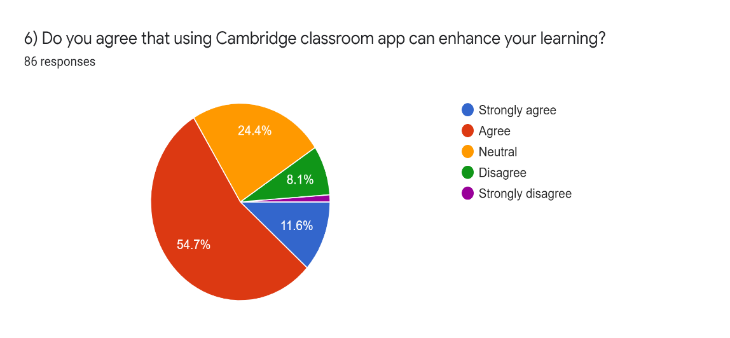

Figure 8

Moreover, the majority of students expressed their support and positive attitude towards improving their learning achievement using Cambridge apps, while 1 in 10 students believed otherwise. In addition, approximately 52.3 % of students expressed their interest in using apps to learn actively and effectively complete the required work or assigned homework. Above all, 60.5% (more than three-fifths) of the students showed a positive tendency and motivation towards the importance of the CCA in improving their overall academic achievement and equipping them with more learning materials.

**Conclusion**

Generally, there is a tendency towards using multimedia as a supplementary tool to learning the four skills. 54% of students believe that Cambridge app would help them enhance their listening skills whereas 63.9% showed interest in learning reading skills. The results coincides with Kim (2013) and (Read & Kukulska-Hulme, 2015) who concluded that the use of media has substantially developed the listening skills for students.

Moreover, a great percent of students expressed the need for more time to be added in the classroom, as two credit hours a week are not enough to properly integrate Cambridge App during the class. Overall, it is recommended that more focus should be given to the use of multimedia in the classroom. Adding more credit hours weekly would possibly make students more inclined to learn without pressure and make teachers more productive in the classroom.

**Recommendations**

The integration of Cambridge mobile apps would help boost the four learning skills for students. Hence, there should be more credit hours assigned at university for teaching Cambridge book series. Two hours are technically not sufficient for a practical fulfillment of such an application. In brief, the researchers recommended that such apps be used side by side with the book itself as they make students more self-independent and more motivated.

**Acknowledgements or Notes**

To all those who died fighting for peace.

**References**

Alsaleem, B.A. (2013). *The Effect of "WhatsApp" Electronic Dialogue Journaling on Improving Writing Vocabulary Word Choice and Voice of EFL Undergraduate Saudi Students*. Arab World English Journal, 4 (3) pp.213-225. Retrieved from: <https://www.awej.org/images/AllIssues/Volume4/Volume4Number3Sept2013/18.pdf>

Anonymous (n.d.). (2011). *A Pedagogical Framework for Mobile Learning: Categorizing Educational Applications of Mobile Technologies into Four Types*. International Review of Research in Open and Distance Learning, 12 (2), pp.1-25. Retrieved from: <https://files.eric.ed.gov/fulltext/EJ920735.pdf>

Baradaran, A., & Kharaziyan, M. A. (2016). *The Impact of Using Mobile Technology on Developing EFL Learners? Writing Skill.* International Journal of English Language and Literature Studies, *5*(2), 135–143. doi: 10.18488/journal.23/2016.5.2/23.2.135.143

Basal, A., Yilmaz, S., Tanriverdi, A., & Sari, L. (2016). *Effectiveness of Mobile Applications in Vocabulary Teaching*. Contemporary Educational Technology, 7(1), pp.47-59. Retrieved from: <https://files.eric.ed.gov/fulltext/EJ1105763.pdf>

Braun, V. & Clarke, V. (2006) *Using thematic analysis in psychology.* Qualitative Research in Psychology, 3 (2). pp. 77-101. Retrieved from: <http://eprints.uwe.ac.uk/11735>

Chee, K. N., Yahaya, N., & Ibrahim, N. H. (2017). Effectiveness of mobile learning application in improving reading skills in Chinese language and towards post-attitudes. *International Journal of Mobile Learning and Organisation*, *11*(3), 210. https://doi.org/10.1504/ijmlo.2017.085347

Chen, X. B. (2013). *Tablets for informal language learning: student usage and attitudes*. Language Learning & Technology 17(1) pp. 20–36. Retrieved from: <https://pdfs.semanticscholar.org/a673/0dfc9fb707a882f955e961563668053ecb96.pdf?_ga=2.34500001.161842048.1580900167-1629428305.1580900167>

Chinnery, G. M. (2006). *Going to the MALL: Mobile assisted language learning.* Language Learning & Technology, *10*(1), 9-16.

Cui, Guoqiang, Wang, & Shuyan. (2008). *Adopting Cell Phones in EFL Teaching and Learning.* Journal of Educational Technology Development and Exchange (JETDE): Vol. 1: Iss. Articl e6. DOI: 10.18785/jetde.0101.06

ENGC2202 Outline. (2021). Retrieved from: <http://www.birzeit.edu/en>.

Gay, G., Stefanone, M., Grace-Martin, M., & Hembrooke, H. (2001). *The effects of wireless collaborative learning environments.* International Journal of Human Computer Interaction, 13(2).

Hea-Suk, K. (2013). *Emerging mobile apps to improve English listening skills.* Multimedia-Assisted Language Learning, 16 (2), pp.11-30. Retrieved from: <https://pdfs.semanticscholar.org/2297/055d0d4171bf0de213978e9f9f2d2a7af24f.pdf?_ga=2.37174944.161842048.1580900167-1629428305.1580900167>

Park, Y. (2011). A pedagogical framework for mobile learning: Categorizing educational applications of mobile technologies into four types. *The International Review of Research in Open and Distributed Learning*, *12*(2), 78. https://doi.org/10.19173/irrodl.v12i2.791

Patton, M. Q. & Cochran, M. (2002). *A Guide to Using Qualitative Research Methodology.* Retrieved from: https://evaluation.msf.org/sites/evaluati on/files/a_guide_to_using_qualitative_research_ ethodology.pdf

Rahimia, M. & Mirib, S.S.(2014). *The Impact of Mobile Dictionary Use on Language Learning*. Social and Behavioral Sciences 98. pp. 1469 – 1474. Retrieved from: <https://core.ac.uk/download/pdf/82156394.pdf>

Read, Timothy and Kukulska-Hulme, Agnes (2015). *The Role of a Mobile App for Listening Comprehension Training in Distance Learning to Sustain Student Motivation.* Journal of Universal Computer Science, 21(10) pp. 1327–1338.

Rezaei, A., Mai, N., & Pesaranghader, A. (2014). The effect of mobile applications on English vocabulary acquisition. *Jurnal Teknologi*, *68*(2). https://doi.org/10.11113/jt.v68.2912

Rosell-Aguilar, F. (2016). State of the app: A taxonomy and framework for Evaluating Language Learning Mobile Applications. *CALICO Journal*, *34*(2), 243–258. https://doi.org/10.1558/cj.27623

Rosell-Aguilar, F. (2007). *Top of the pods-In search of a podcasting “pedagogy” for language learning.* Computer Assisted Language Learning, 20(5), 471-492.

Schenker, T., & Kraemer, A. (2017). Maximizing L2 speaking practice through iPads. *Languages*, *2*(2), 6. https://doi.org/10.3390/languages2020006

Sharples, M., Taylor, J., & Vavoula, G. (2005). *Towards a theory of mobile learning*. Retrieved form:

<https://www.researchgate.net/publication/228346088_Towards_a_theory_of_mobile_learning>

Wu, Qun (2014). *Learning ESL Vocabulary with Smartphones.* Procedia - Social and Behavioral Sciences 143 pp.302 – 307 Retrieved from: <https://core.ac.uk/download/pdf/82630227.pdf>

|  |  |
| --- | --- |
| **Author Information** | |
| **Mohammad Zaid**  <https://orcid.org/0000-0002-4394-7961>  Birzeit University  Birzeit, Ramallah  Palestine  Contact e-mail: *mszaid@birzeit.edu* | **Suzan Shehada**  Açıklama: ORCID [https://orcid.org/0000-0002-4745-059X](https://orcid.org/0000-0002-4745-059X?lang=en)  Birzeit University  Birzeit, Ramallah  Palestine  Contact e-mail: [*sshehada@birzeit.edu*](mailto:sshehada@birzeit.edu) |

**Appendix**

**Students’ Questionnaire**

The following questionnaire is part of a study conducted at the Department of Languages and Translation at Birzeit University. It aims to discover students’ perceptions towards the effectiveness of using the Cambridge classroom apps. Please, answer the questions below carefully and honestly. All the information you provide will be kept strictly confidential and will be used only for academic purposes. Thank you for your cooperation.

**The Researchers**

**Part One: Personal Information.**

➢ Gender: Male_____ Female_____

➢ Age:___________

➢ Major:___________________________________

**Part Two: Mobile apps in learning English.**

1) In which way do you prefer to study?

➢ Lecture and explanation in the classroom

➢ Self-study using books and printed materials

➢ Self-study using mobiles and computers

2) Which of the following devices do you find easy to use for learning English?

Mobiles______ Computers _______

3) Which of the following applications do you use for learning English?

Dictionaries _____ Vocabulary Building _______ Pronunciation______ Spelling_______

Others: ……………………………………………………………………………………………

4) In your opinion, which of the following skills can be developed through mobile applications?

Reading_____ Writing_____ Listening ______ Speaking______

- Would you kindly explain how for each selected skill?

…………………………………………………………………………………………………………………………………………………………………………………………………………………………………………………………………………………………………………………………………………………………………………………………………………………………………………………………………………………………………………………………….................................................................................................................

**Part Three: Attitudes towards using the Cambridge Classroom App and its effect on students’ motivation.**

6) Do you agree that using the Cambridge classroom app can enhance your learning?

Strongly Agree Agree Neutral Disagree Strongly Disagree

7) Do you agree that the use of the Cambridge Classroom App has a positive impact on your learning achievement in general?

Strongly Agree Agree Neutral Disagree Strongly Disagree

8) Do you think that using the Cambridge Classroom app motivates students to study more and work on their assignments?

Strongly Agree Agree Neutral Disagree Strongly Disagree

9) Do you agree that using the Cambridge Classroom App can help students build a large vocabulary range?

Strongly Agree Agree Neutral Disagree Strongly Disagree

11) Do you think that using the Cambridge Classroom App is effective for listening skills?

Strongly Agree Agree Neutral Disagree Strongly Disagree

12) Do you think that the Cambridge Classroom App is effective for speaking activities?

Strongly Agree Agree Neutral Disagree Strongly Disagree

13) Do you agree that the Cambridge Classroom App is an effective tool for writing activities?

Strongly Agree Agree Neutral Disagree Strongly Disagree

14) Do you agree that the Cambridge Classroom App is an effective tool for reading activities?

Strongly Agree Agree Neutral Disagree Strongly Disagree

15) Do you agree that the Cambridge Classroom App helps acquire more learning materials, hence more learning achievements?

Strongly Agree Agree Neutral Disagree Strongly Disagree

**Thank You for Your Contribution**

**Adapted from: Investigating the Impact of Using Mobile Technology on Improving EFL Students’ Learning Achievement: A Case Study**